MEMO
TO: TAGD Stakeholders interested in development of Groundwater Availability Models (GAMs)
FROM: James Beach, P.G. – Project Manager
SUBJECT: Development of Estimates of Recharge and Surface Water- Groundwater Interactions for Aquifers in Central and West Texas
DATE: October 9, 2020

The Texas Water Development Board (TWDB) is mandated to develop regional-scale groundwater availability models (GAMs) for all the major and minor aquifers of Texas. Recharge and surface water-groundwater interactions are an important part of the water budget for the GAMs. TWDB has contracted with WSP, LRE Water, IRP Water, and Dr. Raghavan Srinivasan to develop estimates of recharge and stream baseflow conditions (or groundwater-surface water interactions) for four major aquifers namely, going from East to West, Trinity (Hill Country), Edwards Balcones Fault Zone (BFZ), Edwards-Trinity (Plateau), and Pecos Valley Alluvium. The current project has two objectives, to estimate: a) groundwater recharge, and b) stream baseflow conditions (or groundwater-surface water interactions), in the study area
Figure 1 presents the four aquifers that constitute the region of interest (ROI) for this study. With this data request we intend to gather the following information that was not previously publicly available for the ROI:
- Current or previous study on recharge or surface water- groundwater interactions
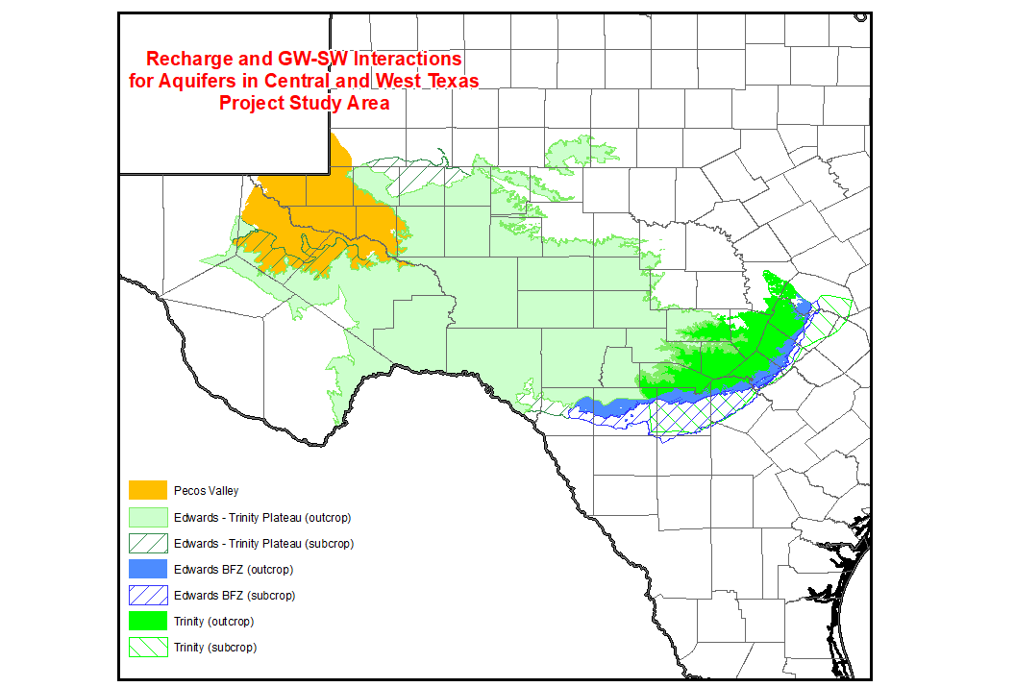
- Local or non-publicly available data on recharge or surface water- groundwater interactions including but not limited to streamflow, springflow, infiltration, evaporation, etc.
Figure 1. Region of Interest for the Project
In order to meet the TWDB deadline for compilation of this data, we ask that you provide any information or data on or before November 10, 2020. Data may be provided via email or other digital transfer method to james.beach@wsp.com
Your cooperation and response are crucial to assisting the State in developing acceptable GAMs, estimating current and future groundwater availability, and planning for and providing ongoing funding opportunities to help ensure Texas communities and citizens have adequate water supplies.

