MEMO
TO: TAGD Stakeholders interested in buffers zones around Class II injection wells for delineation of BRACS production zones
FROM: Rohit Goswami, Ph.D., P.E. – Project Manager
SUBJECT: Development of Procedures and Tools to Delineate Areas Designated or Used for Class II Well Wastewater Injectate
DATE: October 9, 2020

TWDB was mandated, with the passage of House Bill (HB) 30 in the 84th Texas Legislature, to designate brackish groundwater production zones in the state to reduce the use of fresh groundwater. HB 30 laid out certain criteria for designation of the brackish groundwater production zones - an important one being that such zones cannot be identified “in an area of a geologic stratum that is designated or used for wastewater injection through the use of injection wells or disposal wells permitted under Chapter 27”. To fulfill this criterion, TWDB had previously applied a conservative buffer of 15 miles around all Class II injection wells identified within mapped brackish aquifer zones.
TWDB has contracted with the WSP project team including S.S. Papadopulos & Associates, Gustavson Associates, and Dr. Jack Sharp to develop procedures and tools that may be applied to more accurately map the buffer zones around the existing and future Class II injection wells that lie within identified brackish aquifers in the state. Figure 1 presents the 18 TWDB-identified aquifers that constitute the region of interest (ROI) for this study. With this data request we intend to gather any relevant information in the ROI pertaining to the following main desired attributes for Class II injection wells:
- Monthly or daily water injection volume
- Formation porosity and permeability
- Formation depth, temperature (surface temperature and temperature gradient)
- Formation pressure and hydraulic gradient
- Injectate and formation water salinity and density
- Screen depth and interval
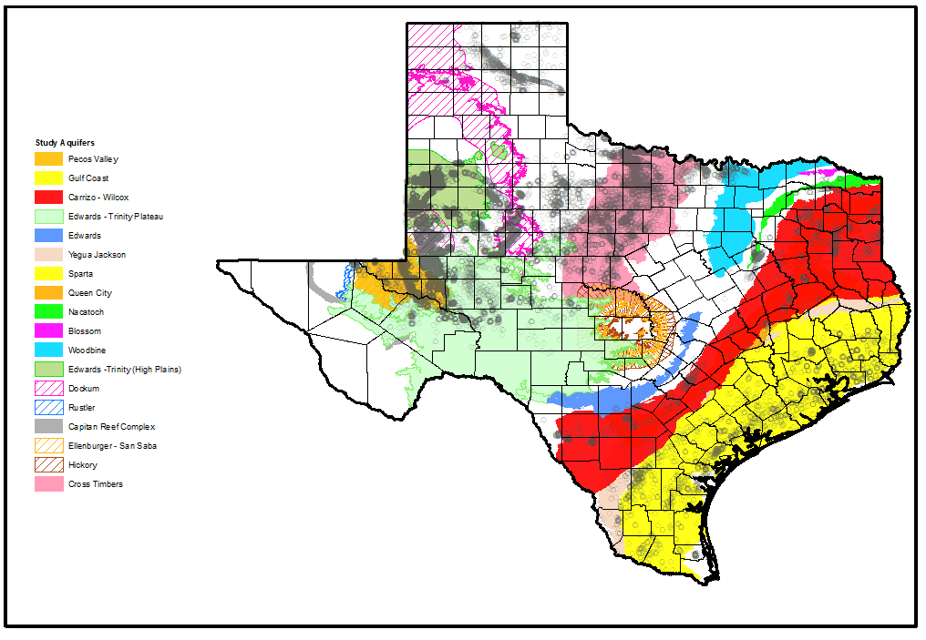
- Class II injection well logs
Figure 1. Location of identified Class II injection wells & Study Aquifers for the Project
In order to meet the TWDB deadline for compilation of this data, we ask that you provide any information or data on or before November 10, 2020. Data may be provided via email or other digital transfer method to myself at rohit.goswami@wsp.com or to Mr. Brad Cross with WSP at brad.cross@wsp.com.
Your cooperation and response are crucial to assisting the State in delineating appropriate brackish groundwater production zones and providing ongoing funding opportunities to help ensure Texas communities and citizens have adequate water supplies.

